



Index

Objective
Acknowledgement
Introduction
Project Description
Existing System
Proposed System
Scope of the system
System Analysis
Feasibility Study :
- Technical Feasibility
- Economical Feasibility
- Operation Feasibility
Data Dictionary
System Design :
- Use Case Diagram
- DFD (Data Flow Diagram)
- Zero Level
- First Level
- E – R (Entity Relationship) Diagram
- Active Diagram
Input / Output
Report
Conclusion
Limitation
Future Enhancement
Software Requirements
Hardware Requirements
Bibliography
Objective

The main aim and objective of this project is use to manage the details of Shop, Sales, Purchase, Payment, Charges and Stock Management.
Super Shopee is a project based on real Shop, main purpose of creating project is to reduce manual work for managing the Shop, Sales, Purchase, Payment, Charges, Customer details, Supplier details and Stock Management.

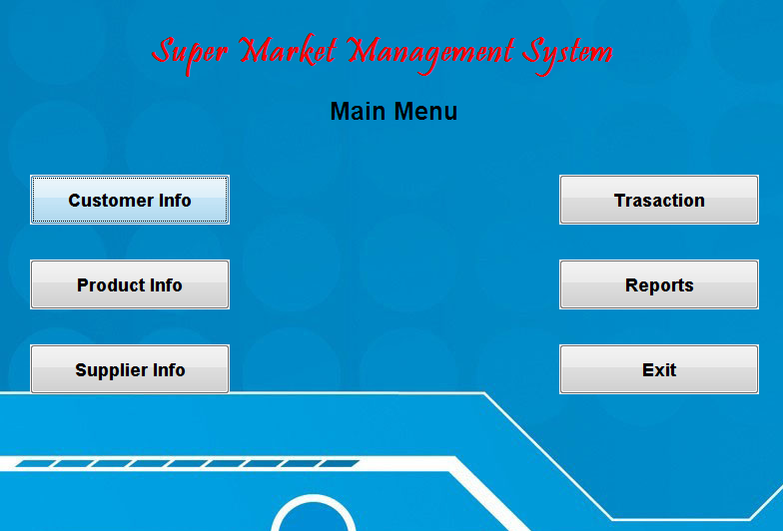
Acknowledgement

I heartily like to thanks my College and my Department who gave me this opportunity to express my gratitude towards my teachers who have helped me a lot for completing my project.

I am very grateful towards my lecturer, Prof.(Ashwini Thopte), Prof.(Insha Shaikh), Prof.(Sameena Jamadar), Prof.(Niraj Bagwe), Prof.(Samad Khan) and all faculties members who have helped me to accomplished my project and guided me throughout it and also like to thanks our HOD Dr.(Alifiya Jahagirdar) who gave invaluable support and relentless efforts whole time.

Last, but not the least, I genuinely like to say thank you to all friends & my lab instructor whose suggestion help me a lot while the project work was in progress and I am also grateful to non-teaching staff to help me in laboratory and in various ways. So with due regards, I express my gratitude towards them.
Introduction

The "Super Shopee" has been developed to override the problems prevailing in the practicing manual system. This software is supported to eliminate and in some cases reduce the hardships faced by this existing system. Moreover this system is designed for the particular need of the company to carry out operations in a smooth and effective manner.
The application is reduced as much as possible to avoid errors while entering the data. It also provides error message while entering invalid data. No formal knowledge is needed for the user to use this system. Thus by this all it proves it is user-friendly. It can lead to error free, secure, reliable and fast management system. It can assist the user to concentrate on their other activities rather to concentrate on the record keeping. Thus it will help organization in better utilization of resources.
Every organization, whether big or small, has challenges to overcome and managing the information of Customer, Supplier, Sales, Purchase, and Payments. This is designed to assist in strategic planning, and will help you ensure that your organization is equipped with the right level of information and details for your future goals.

Project Description

The Objective of this project is to develop a system that automates the process of maintaining sale, purchase, stock, customer and supplier details. The purpose is to design a system using which one can perform all operations related to shop.
This System maintains & controls the database of customer and supplier information.

The system mainly organizes the shop information. The main purpose behind to make this system for effective & efficient work. To make the security system computerizes & maintains the records.

Existing System

- The existing system is maintained by manually, which in turn caused dependency between colleagues.

- It is not easy to keep the all information about the shop manually, because procedure is very and theoretical.

- Sometimes information may get lost because of its writing in the books and register.

- It also led to loss of time & energy.

- The records or transaction are not to be properly maintained.

- Sometimes it provides inaccurate calculation and information.

- The process of purchase, billing and selling is lengthy. Difficult to maintain the customer details of package and payment receipt in register.

- It consist lot of paper work, which was difficult to manage.
Proposed System

The function provide by the proposed system as follows,

- It is utilize the accuracy of work.
- Proper maintenance of information about the shop.
- It also provides the service like selling, purchasing, billing, saving of data.
- It is very easy to insert, update, delete, modify & retrieve data from the database.
- It reduces the redundancy & duplication of information about the stock.
- The system had to eradicate all the disadvantage of the old system and prove its superiority.
- New system has ability to get things done at very rapid rate.
- The system stress information and provides it when actually needed.
- The system is accurate in calculation of a very accurate manner.
- It can’t be access unauthorized person because it’s security.
Scope of the system

- To assist the staff in capturing the effort spent on their respective working areas.
- To utilize resources in an efficient manner by increasing their productivity through automation.
- The system generates types of information that can be used for various purposes.
- It satisfies the user requirement.
- Be easy to understand by the user and operator.
- Be easy to operate.
- Has a good user interface.
- Be expandable.
- Delivered on schedule within the budget.
System Analysis
Major tasks performed in the existing system :
- Customer Information
- Supplier Information
- Item Information
- Sales Information
- Purchase Information
- Generation of Sales Bill
- Generation of Purchase Order

Detail of sales transaction :
If the customer is regular customer then his ID is found out and sales order for that customer is entered. Then the bill is generated. If the customer is not the regular user then his information is filled first. Then the customer buys the required item then goes to the bill counter.

Detail of purchase transaction :
When the supplier gives the item, a bill is received from him. We store the details of the supplier and bill information. Manager gives supplier payment and that information is also being stored.

Problem faced in the manual system :
In the existing manual, it is very difficult to keep the records of the customers.
It is also very difficult to keep track of discount, other facilities and cost for each item.
It is tedious to prepare monthly & yearly sales reports.

Disadvantages of the existing system :
A lot of paper work is required as system is manual. Hence maintenance of data is not easy.
Man power requirement is more in existing system.

Less Accuracy:
Manual errors in data entry & reports are more.

Data Redundancy:
Different types of record are stored in various registers. Retrieval of such records is a time consuming process which may reduce working efficiency.

Feasibility study

The feasibility study is useful to evaluate the cost and benefit of the system requested. The feasibility study tries to anticipate future scenarios of software development. There are three major aspects in the Feasibility Study.

TECHNICAL FEASIBILITY:
Technically the system is possible to develop with available Hardware & Software. The proposed system had developed with available software application, development tools, JAVA 1.6 and Microsoft Access as background.

OPERATIONAL FEASIBILITY:
Proposed projects are beneficial only if they can be turned out into information systems, which will meet the organization’s operating requirements. Operational feasibility aspects of the project are to be taken as an important part of the project implementation.

The proposed system is not trying to develop new methods but it is following the same existing convention and general rules, which guides several processes and it is just automatic of manual system for better efficiency and accuracy. So it is expected that user will not feel alien to the system.
Operationally, the system is feasible to implement, as it will be easy to learn and understand.

ECONOMIC FEASIBILITY:
A system can be developed technically and that will be used if installed must still be a good investment for the organization. In the economical feasibility, the development cost in creating the system is evaluated against the ultimate benefit derived from the new systems. Financial benefits must equal or exceed the costs.
The system is economically feasible. It does not require any additional hardware or software.
Economically, the system is feasible because the company already has the necessary Hardware and Software requirement’s initially the investment is not required. Also the system will save the time. Enhance work speed and also reduce manual work and documentation. Cost of project development was found much less then benefits.
Data dictionary
Supper Shopee DataBase
Supplier
Name | Data Type | Constrain | Description
sno | number | Not null | Store supplier no
sname | number |  | Store supplier name
saddr | text |  | Store supplier address
sphone | text |  | Store supplier phone

Product
Name | Data Type | Constrain | Description
pno | number | Not null | Store product number
pname | Text |  | Store product name
pdesc | Text |  | Store product description
pqty | number |  | Store quantity of product
prate | number |  | Store price of product

Customer
Name | Data Type | Constrain | Description
cno | number | Not null | Store customer number
cname | Text |  | Store customer name
caddr | Text |  | Store customer address
cpnone | Text |  | Store customer phone

Purchase
Name | Data Type | Constrain | Description
trans_no | number | Not null | Store name
Sno | number | Not null | Store age
Sname | text |  | Store gender
Billno | number |  | Store email id
Date | text |  | Store phone number
ino1 | number |  | Store item no
iname1 | text |  | Store item name
iqty1 | number |  | Store item quantity
irt1 | number |  | Store item rate
iramt1 | number |  | Store item amount
ino2 | number |  | Store item no
iname2 | text |  | Store item name
iqty2 | number |  | Store item quantity
irt2 | number |  | Store item rate
iramt2 | number |  | Store item amount
ino3 | number |  | Store item no
iname3 | text |  | Store item name
iqty3 | number |  | Store item quantity
irt3 | number |  | Store item rate
iramt3 | number |  | Store item amount
ino4 | number |  | Store item no
iname4 | text |  | Store item name
iqty4 | number |  | Store item quantity
irt4 | number |  | Store item rate
iramt4 | number |  | Store item amount
ino5 | number |  | Store item no
iname5 | text |  | Store item name
iqty5 | number |  | Store item quantity
irt5 | number |  | Store item rate
iramt5 | number |  | Store item amount
ino6 | number |  | Store item no
iname6 | text |  | Store item name
iqty6 | number |  | Store item quantity
irt6 | number |  | Store item rate
iramt6 | number |  | Store item amount
Total | number |  | Store total amount

Sales
Name | Data Type | Constrain | Description
billno | number | Not null | Store name
cno | number | Not null | Store age
cname | text |  | Store gender
date | text |  | Store phone number
ino1 | number |  | Store item no
iname1 | text |  | Store item name
iqty1 | number |  | Store item quantity
irt1 | number |  | Store item rate
iramt1 | number |  | Store item amount
ino2 | number |  | Store item no
iname2 | text |  | Store item name
iqty2 | number |  | Store item quantity
irt2 | number |  | Store item rate
iramt2 | number |  | Store item amount
ino3 | number |  | Store item no
iname3 | text |  | Store item name
iqty3 | number |  | Store item quantity
irt3 | number |  | Store item rate
iramt3 | number |  | Store item amount
ino4 | number |  | Store item no
iname4 | text |  | Store item name
iqty4 | number |  | Store item quantity
irt4 | number |  | Store item rate
iramt4 | number |  | Store item amount
ino5 | number |  | Store item no
iname5 | text |  | Store item name
iqty5 | number |  | Store item quantity
irt5 | number |  | Store item rate
iramt5 | number |  | Store item amount
ino6 | number |  | Store item no
iname6 | text |  | Store item name
iqty6 | number |  | Store item quantity
irt6 | number |  | Store item rate
iramt6 | number |  | Store item amount
total | number |  | Store total amount

System Design

Use Case diagram
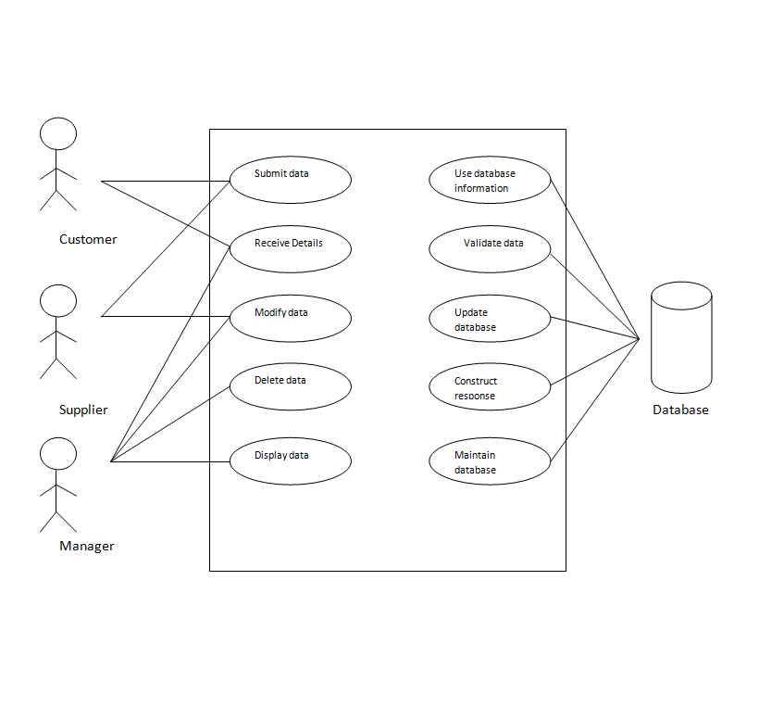

Data Flow Diagram

Zero Level DFD
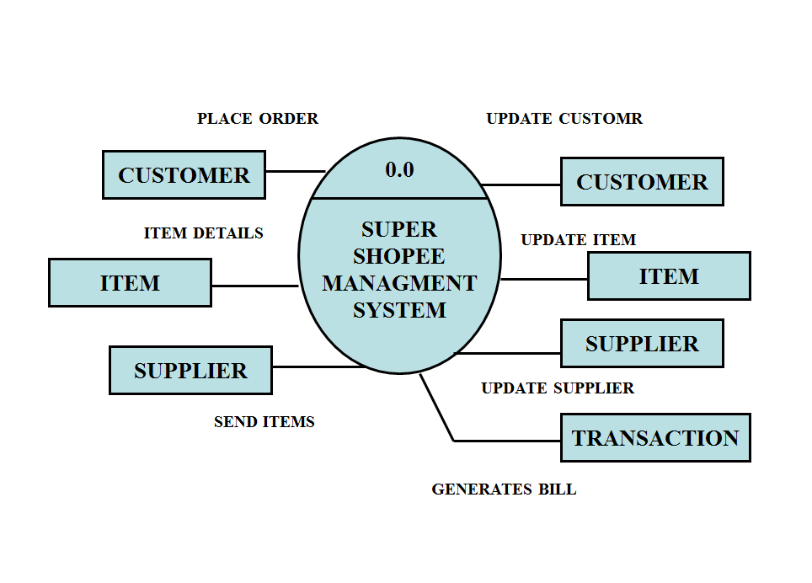

First Level DFD
(P.T.O)
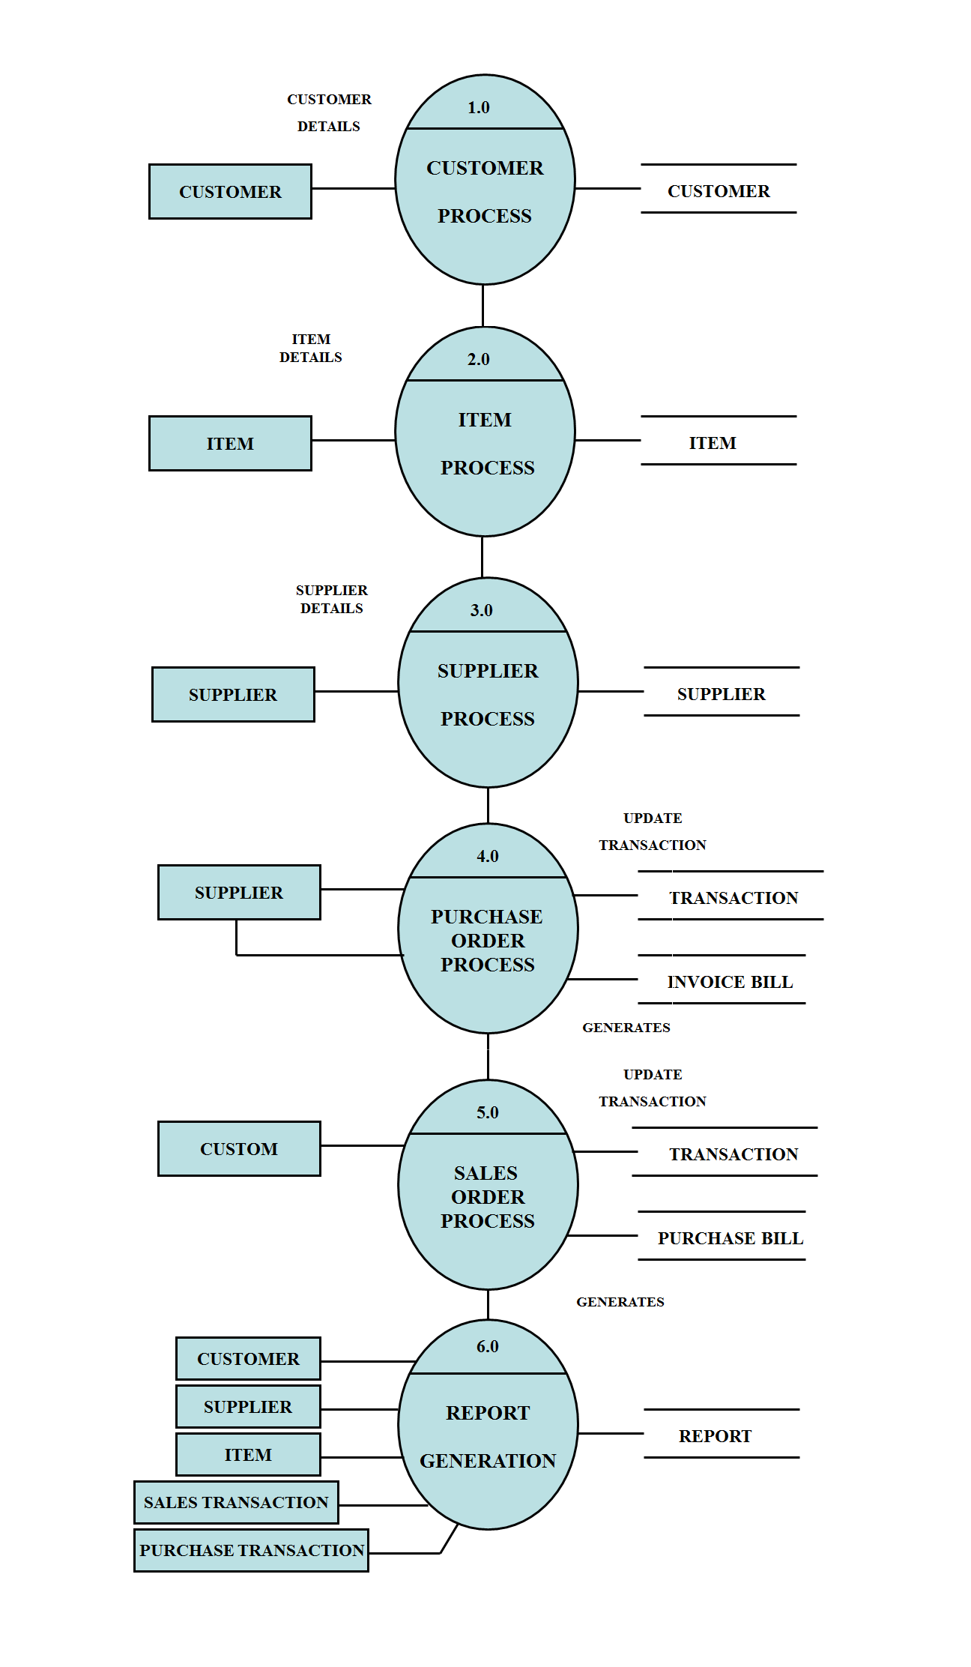

ER Digram
(Entity Relationship)

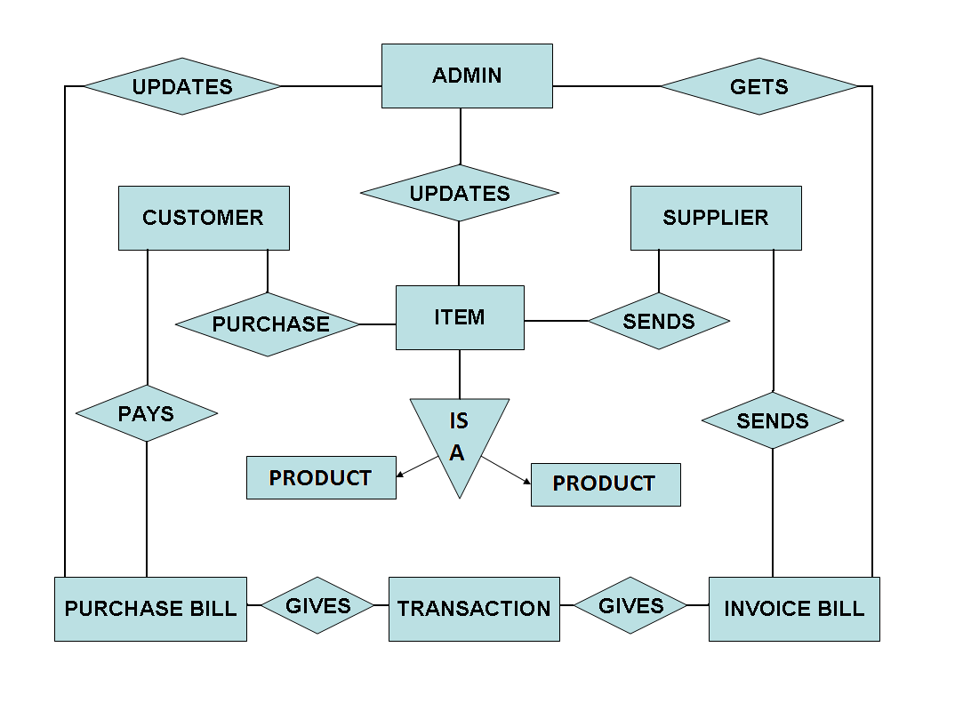

Activity Diagram

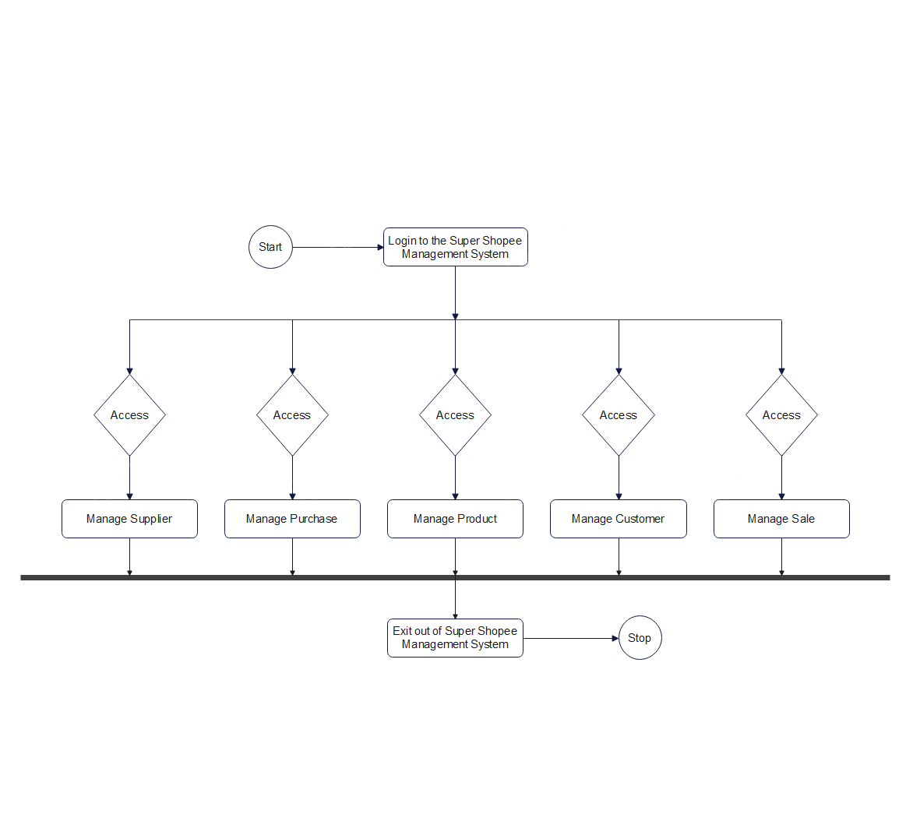

Class Diagram

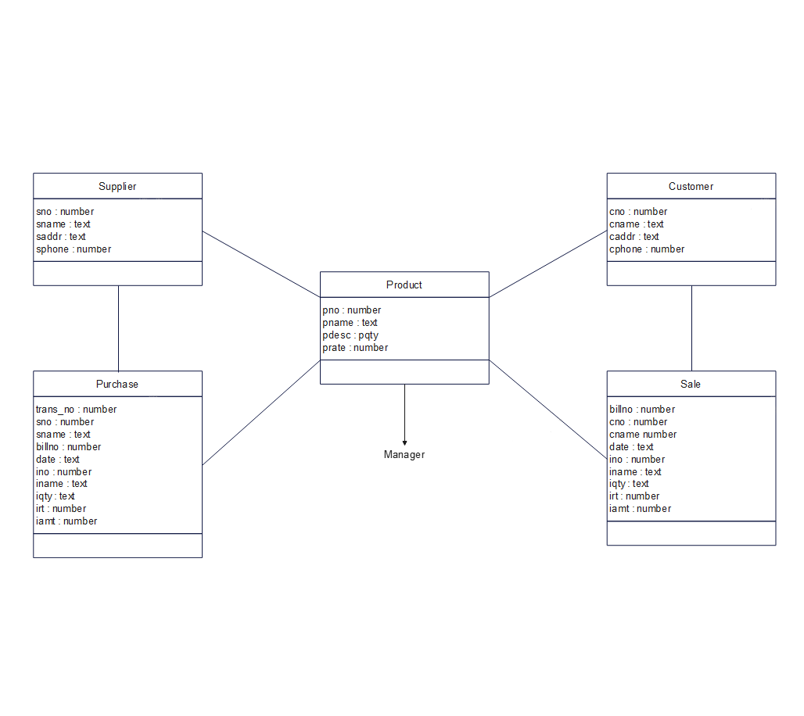

Deployment Diagram

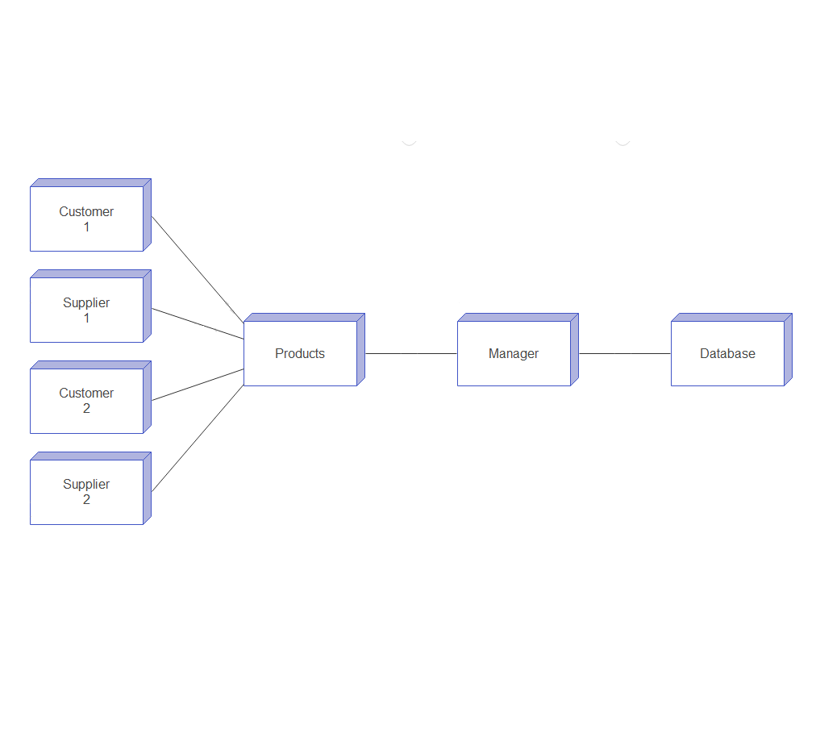

Input / Output

This is first page for login where you can login into the real application with username “admin” and password as “admin”.

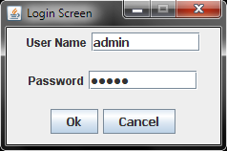

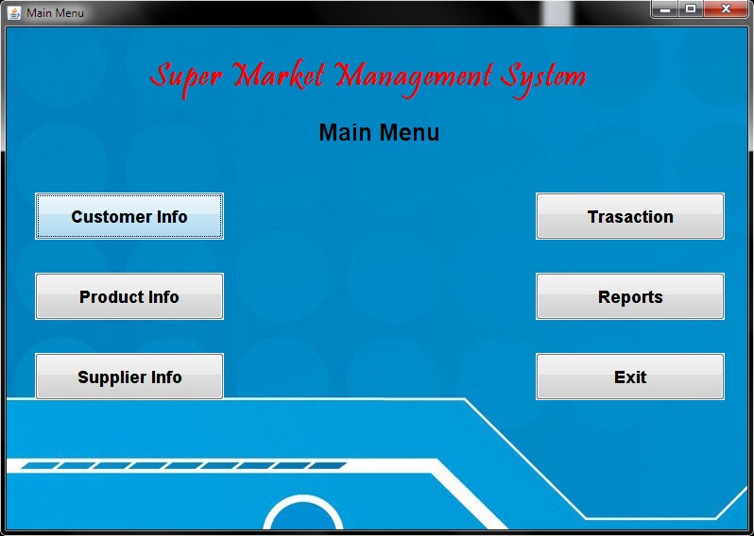

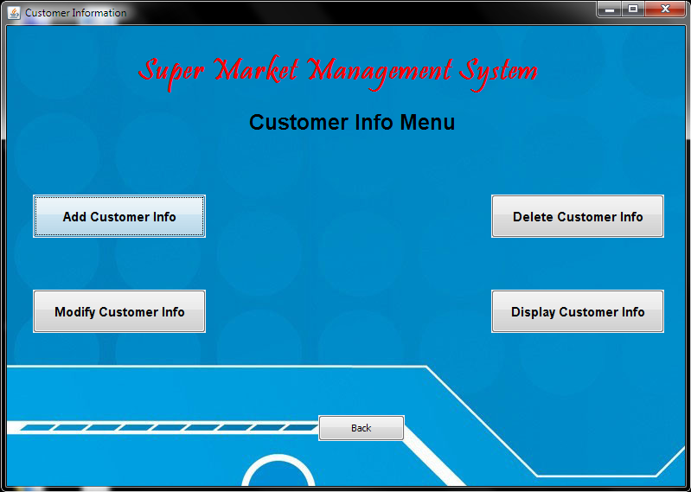
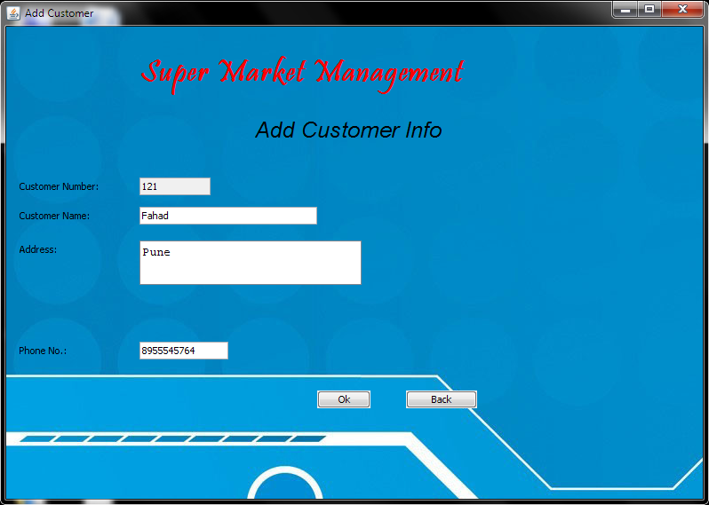

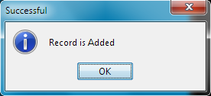

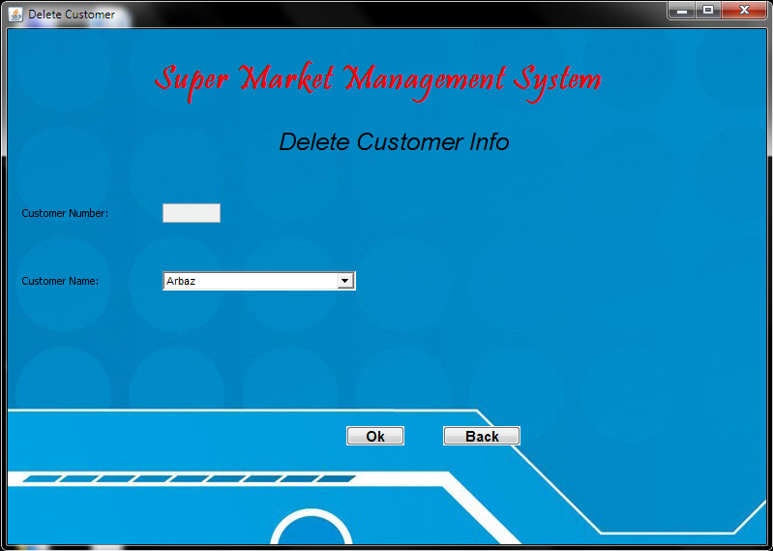

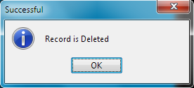
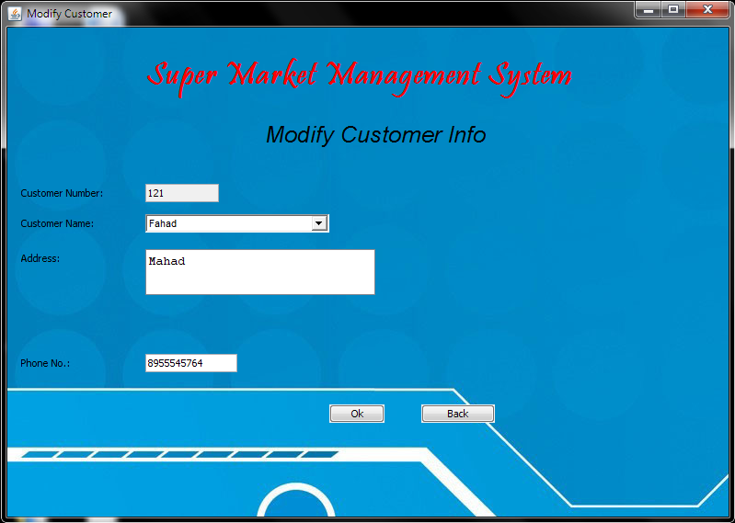

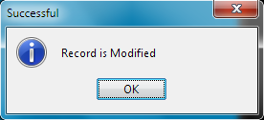
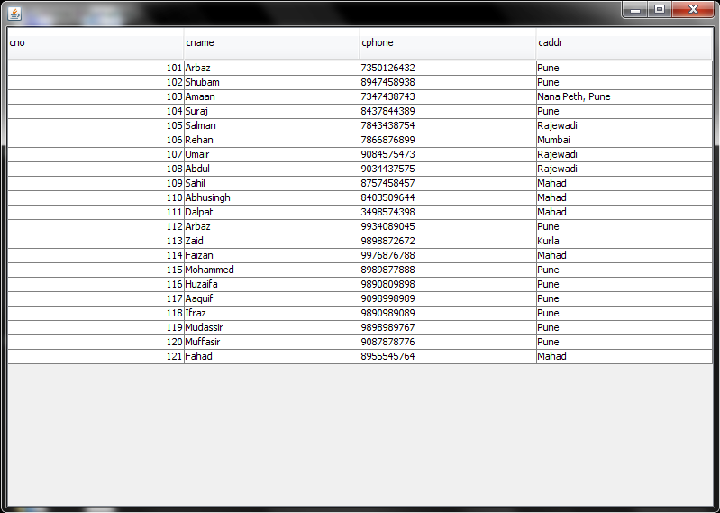

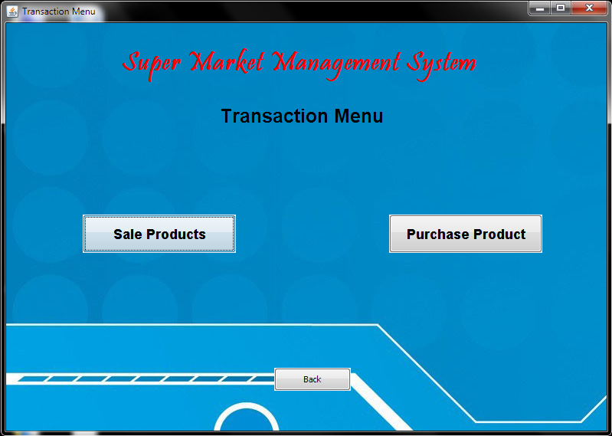
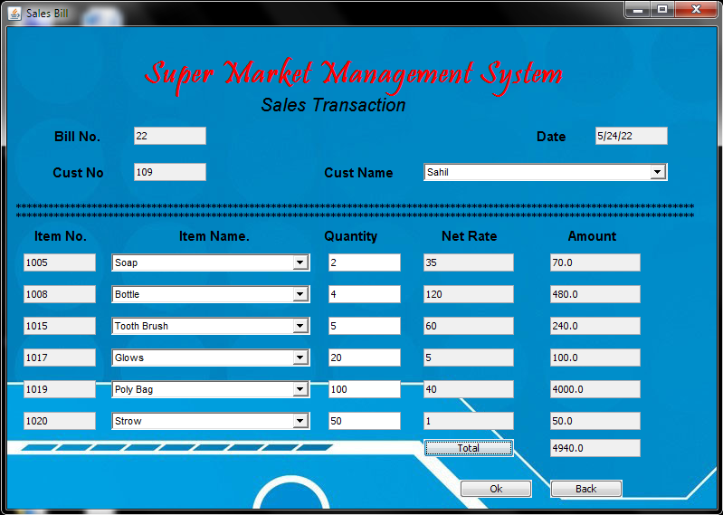

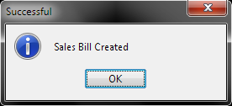

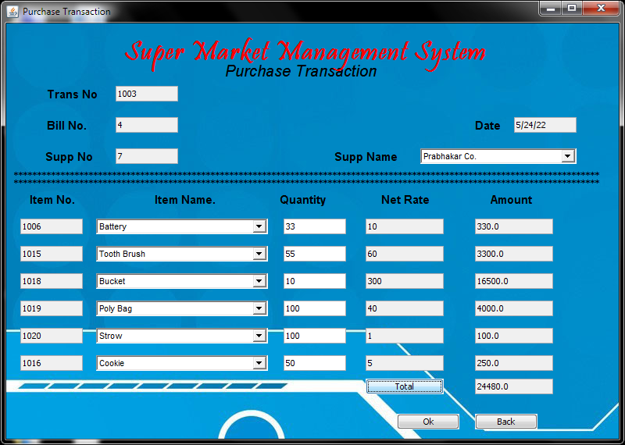

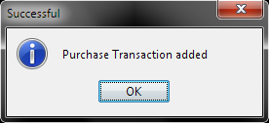
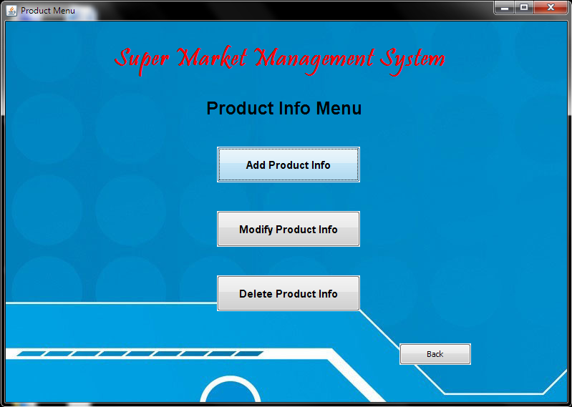

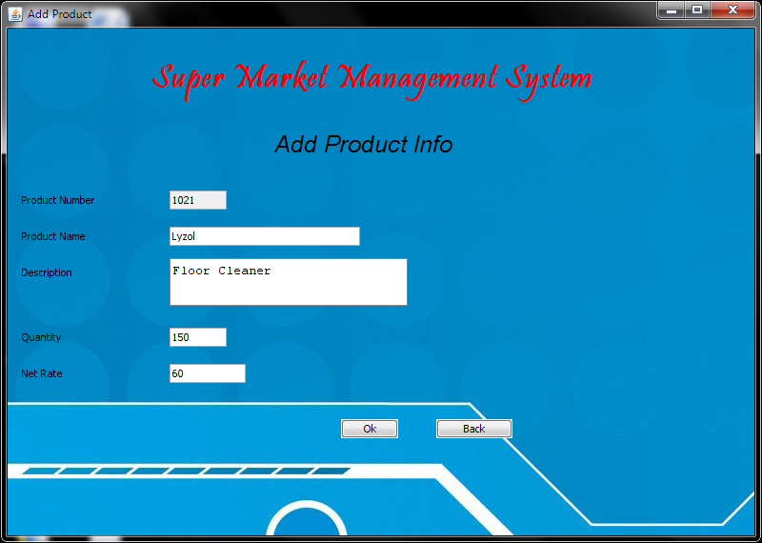


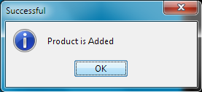

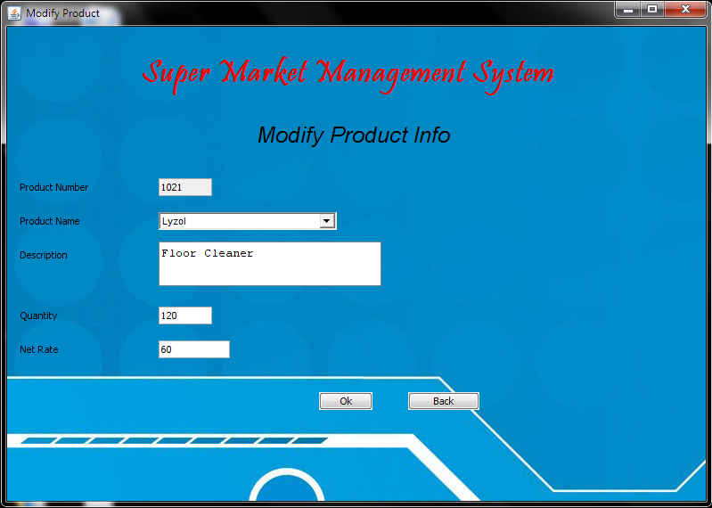

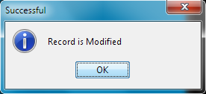

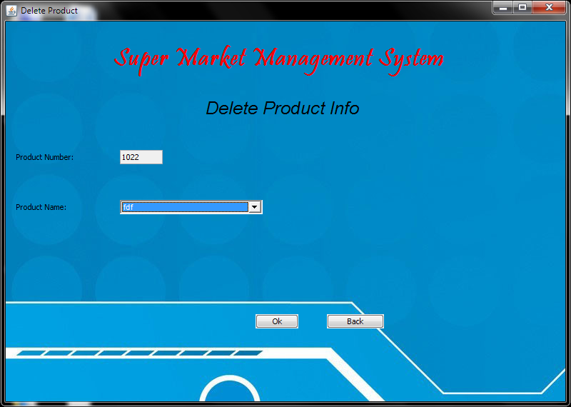

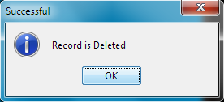

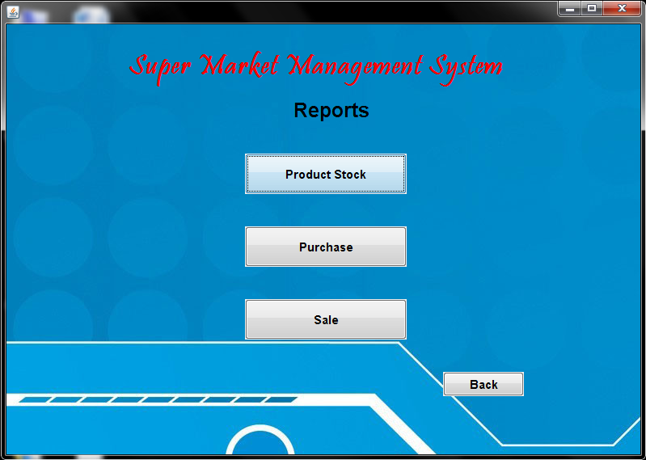
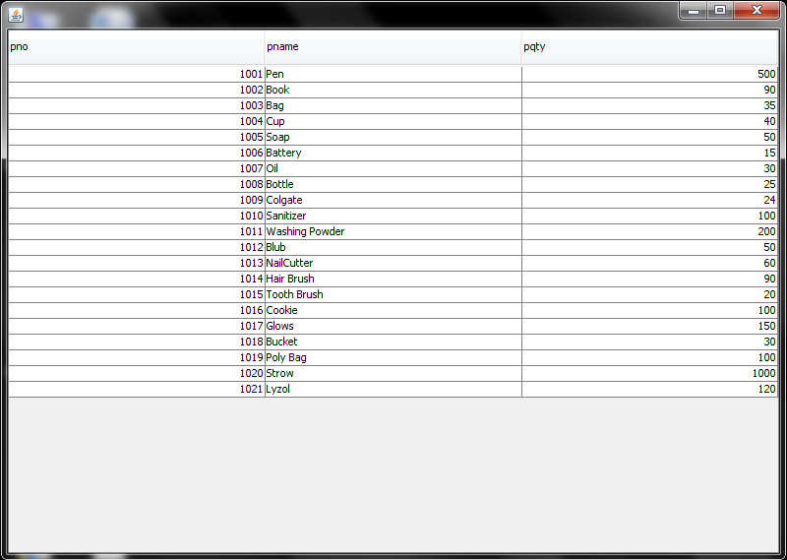

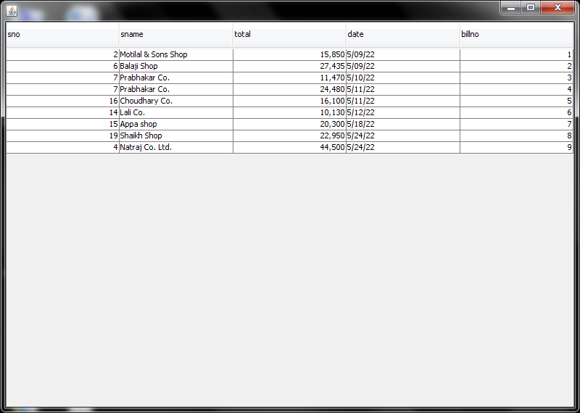
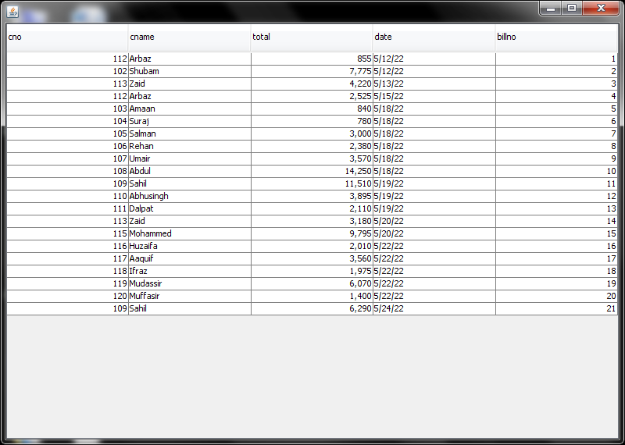


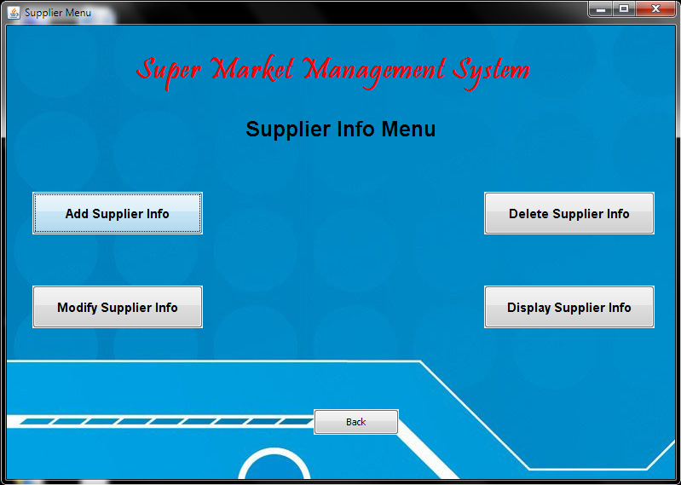
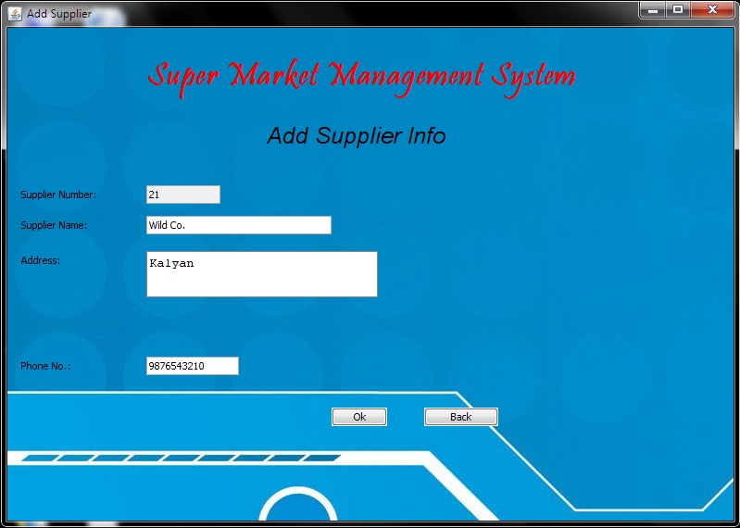

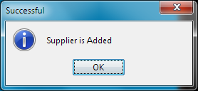
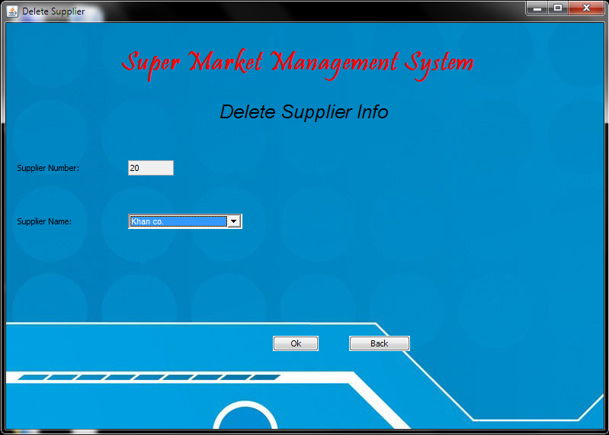

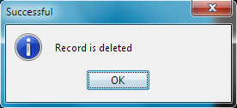
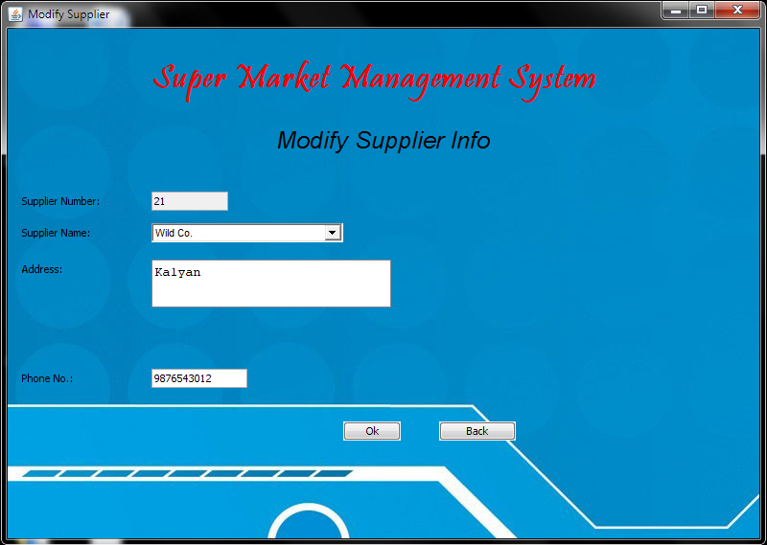

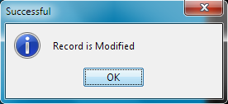
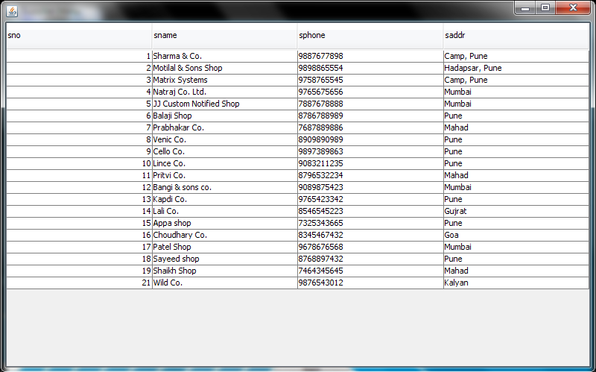

Click “Exit” to close the window.

Report
Report for Product Stock :
Product stock
pno | pname | pqty
1001 | Pen | 500
1002 | Book | 90
1003 | Bag | 35
1004 | Cup | 40
1005 | Soap | 50
1006 | Battery | 15
1007 | Oil | 30
1008 | Bottle | 25
1009 | Colgate | 24
1010 | Sanitizer | 100
1011 | Washing Powder | 200
1012 | Blub | 50
1013 | Nail Cutter | 60
1014 | Hair Brush | 90
1015 | Tooth Brush | 20
1016 | Cookie | 100
1017 | Glows | 150
1018 | Bucket | 30
1019 | Poly Bag | 100
1020 | Straw | 1000
1021 | Lyzol | 120

Report for Product sold :
Sales Dettails
Eno | ename | total | datee | billno
112 | Arbaz | 855 | 5/12/22 | 1
102 | Shubam | 7775 | 5/12/22 | 2
113 | Zaid | 4220 | 5/13/22 | 3
112 | Arbaz | 2525 | 5/15/22 | 4
103 | Amaan | 840 | 5/18/22 | 5
104 | Suraj | 780 | 5/18/22 | 6
105 | Salman | 3000 | 5/18/22 | 7
106 | Rehan | 2380 | 5/18/22 | 8
107 | Umair | 3570 | 5/18/22 | 9
108 | Abdul | 14250 | 5/18/22 | 10
109 | Sahil | 11510 | 5/19/22 | 11
110 | Abhusingh | 3895 | 5/19/22 | 12
111 | Dalpat | 2110 | 5/19/22 | 13
113 | Zaid | 3180 | 5/20/22 | 14
115 | Mohammed | 9795 | 5/20/22 | 15
116 | Huzaifa | 2010 | 5/22/22 | 16
117 | Aaquif | 3560 | 5/22/22 | 17
118 | Ifraz | 1975 | 5/22/22 | 18
119 | Mudassir | 6070 | 5/22/22 | 19
120 | Muffasir | 1400 | 5/22/22 | 20
109 | Sahil | 6290 | 5/24/22 | 21

Report for Product purchase :
Purchase Details
sno | Sname | total | date | Billno
2 | Motilal & Sons Shop | 15850 | 5/09/22 | 1
6 | Balaji Shop | 27435 | 5/09/22 | 2
7 | Prabhakar Co. | 11470 | 5/10/22 | 3
7 | Prabhakar Co. | 24480 | 5/11/22 | 4
16 | Choudhary Co. | 16100 | 5/11/22 | 5
14 | Lali Co. | 10130 | 5/12/22 | 6
15 | Appa shop | 20300 | 5/18/22 | 7
19 | Shaikh Shop | 22950 | 5/24/22 | 8
4 | Natraj Co. Ltd. | 44500 | 5/24/22 | 9

Conclusion

In this project we study the shop management system. It is developed in Java and the database has been built in Microsoft Access only, keeping in mind the specifications of the system, Apart from MS-Access the organization have also implemented other database software like Oracle or SQL. For elaborating the system we have used simple data flow diagrams.

Overall the project teaches us the essential skills like:

- Using system analysis and design techniques like data flow diagram in designing the system.

- Understanding programming logic and language along with utilities like reports, forms, queries etc. in Eclipse, Jcreator and PL/SQL.

Limitation

- The limitations of the shop management system is not knowing an exact stock count in the middle of the period and running the risk of stock outs.

- With the shop management system, the company knows the stock level with certainty only when it physically counts the inventory at the end of each shop.

- Throughout the period, the company takes customer orders without knowing the exact inventory count or whether enough products are available to meet customer demand.

- The limitations of a shop management system include a false sense of reliability and dependence on human entry.

- Although a shop management system updates each time a transaction enters the system, it might lack information regarding stolen, damaged or scrapped units.

- The company remains unaware of the theft or waste, known as shrinkage, until it performs a physical count at least once per year.

- The other limitation is that an employee might enter data incorrectly, introducing inaccurate information that can compromise decision-making.

Future Enhancement

The project has a very vast scope in future.
Project can be updated in near future as and when requirement for the same arises, as it is very flexible in terms of expansion. With the proposed software of database Space Manager ready and fully functional the client is now able to manage and hence run the entire work in a much better, accurate and error free manner.

The following are the future scope for the project.

- System will provide facility of paying online and credit card.

- System will provide facility of generating order acceptance note.

- System will be still more user friendly & easy to use.
Software Requirements

- Operating System: Windows XP, Windows7, Windows8, Windows10, Windows11.

- Language: Java

- Database: Microsoft Access

- Software Development Kit: Notepad, Notepad++, Sublime Text, Visual Studio, CMD, JDK, Jcreator Pro or Eclipse.

Hardware Requirements

- Hardware : >= Processor Pentium III 630MHz

- RAM : >= 512 MB

- Hard disk : >= 50 GB

- Monitor : Color monitor

- Keyboard : 122 key

- Mouse : Wired or Wireless

Bibliography
- Reference :
- Core Java and Adv. Java
- DBMS
- Software Engineering

- Website Reference :
- www.google.com
- www.youtube.com
- www.w3schools.com
- www.geeksforgeeks.com

- Software Reference:
- Notepad ++
- JDK
- Jcreator Pro, Eclipse
- CMD



